# Uber Database:

By Milit Panchasara

## Estimated Tables:

Below Mentioned Entities are divided into multiple Schemas (Riders, Drivers, Admins, dbo (default))

* Admins.Admins *(Admin User Data)*
  + (ID, FirstName, LastName, Email, ContactNumber, Password)
* RideTypes *(Details of rides e.g., UberMoto, UberPull, etc. & other details)*
  + (RideTypeID, RideName, PricePerKm, SeatingCapacity)
* Locations *(Different Location data & co-ordinates)*
  + (LocationID, LocationName, Longitude, Latitude)
* Trips *(Details of trips done by Riders)*
  + (TripID, RiderID, DriverID, SourceLocationID, DestinationLocationID, RideTypeID, StartTime, EndTime, Status, EstimatedFairAmount, ActualFairAmount, PaymentMethod, CancelledBy)
* Riders.Offers *(Offers data for riders)*
  + (OfferID, OfferCode, Description, StartDate, EndDate)
* Riders.Riders *(Basic details of Riders)*
  + (RiderID, FirstName, LastName, Email, EmailVerified, IsNew, ContactNumber, Password, IsBlocked, IsLoggedIn, SessionExpiresIn, Country)
* Riders.SavedPaymentModes *(Details of payment modes saved by users)*
  + (RiderID, PaymentMode, CardNumber, CardDate, CardName)
* Riders.Ratings *(Riders rating given by drivers)*
  + (RatingID, RiderID, DriverID, TripID, Comments, MediaAttached, Rating)
* Riders.ApplicableOffers *(Offers data for riders)*
  + (RiderID, OfferID, IsDisabled)
* Drivers.Drivers *(Basic details of Drivers)*
  + (DriverID, FirstName, LastName, Email, ContactNumber, Password, TotalRidesDone, TotalRidesCancelled, Salary, CurrentRideTypeID)
* Drivers.DriverDetails *(Details of all Drivers e.g., document links, address, Salary, etc.)*
  + (DriverID, DrivingLicense, AadharCard, PanCard, OtherDocument, CurrentAddress, Country, PermenantAddress)
* Drivers.Vehicles *(Vehicles data used by drivers)*
  + (VehicleID, VehicleBrand, VehicleName, RegistrationNo, DocumentLink, VehicleType)
* Drivers.Ratings *(Drivers rating data given by Riders)*
  + (RatingID, DriverID, RiderID, TripID , Comments, MediaAttached, Rating)
* Drivers.Incentives *(Data of Incentives provided to Drivers)*
  + (IncentiveID, Description, StartDate, EndDate)
* Drivers.ApplicableIncentives *(Data of Incentives provided to Drivers)*
  + (DriverID, IncentiveID, IsDisabled)

*Note: CreatedAt & ModifiedAt timestamps will be added to all tables.*

## ER Diagram:

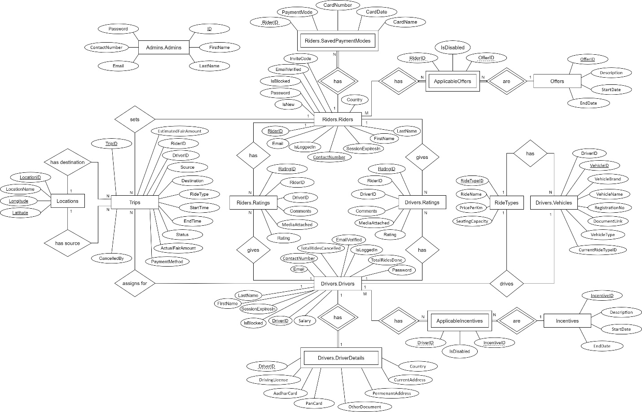

PDF: <https://drive.google.com/file/d/1oPayB9RBH5RQsk9xsygPAWtDrPTKQVjB/view?usp=sharing>

## Estimated Views:

* Riders.vRiders
  + *Modification, Data-read of data will happen through this view, does not contain important data like passwords*
* Drivers.vDrivers
  + *Modification, Data-read of data will happen through this view, does not contain important data like passwords*
* Riders.RiderCredentials
  + *Contains crucial data like password, but has restricted access to read only*
  + *insertion, deletion, modification not allowed*
* Drivers.DriverCredentials
  + *Contains crucial data like password, but has restricted access to read only*
  + *insertion, deletion, modification not allowed*
* vCurrentTrips
  + *Contains data of ongoing trips only i.e., Status = ‘Current’*

## Estimated Stored Procedures:

* Riders.usp_SaveRiderData
* Riders.usp_GetRiderData
* usp_SaveLocationData
* usp_GetLocationData
* usp_GetRideTypesData
* usp_SaveRideTypesData
* usp_DeleteRideTypesData
* usp_SaveNewTripData
* usp_UpdateTripData
* Riders.usp_GetTripsData
* Riders.usp_GetCurrentTripData
* Riders.usp_SaveRatingData
* Admins.usp_GetAllUsersData
* Admins.usp_BlockUnblockUser
* Drivers.usp_SaveDriverData
* Drivers.usp_GetDriverData
* Drivers.usp_SaveVehicleData

## Future Scope of Modifications & Additions:

* Data of offer used by rider is not stored which can be stored with the trips data.
* Tables related to Customer Care System can be added.
* Stored Procedures to Insert, Update, Delete are not implemented for some tables which can be implemented later as per requirement.